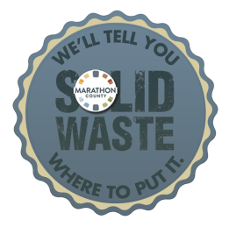

VSQG Chemical Inventory/Program Registration

Business/Generator Name:
Mailing/Street Address:
City, State, Zip Code:
Contact Persons: |  |  |  | Telephone:
County of Business/Residence: |  |  |  | Business Fax:
E-Mail Address:

Please weigh your materials (in their containers). The quotation may be based upon the weight provided.

Waste Name  /Description | Number of  Containers | Container  Size | Total Amount  In Pounds
Sample: Diazinon | 3 | 1-gallon | 24 pounds
Free Technical Assistance is available to complete this form at 715-446-3101 EXT. 100.
Attach additional sheet(s) if necessary. Explosive and ordnance, radioactive material, and infectious
wastes will not be accepted.

Please scan or e-mail this completed form to Julie.Groshek@co.marathon.wi.us;
fax to (715) 446-2906, attention: Julie, or mail to:

Marathon County Solid Waste Department

Attn: Julie

R18500 E. HIGHWAY 29

Ringle, WI 54471

